* **Activity 12:**

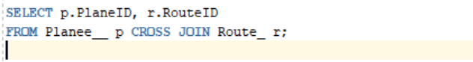Creating Cross Joins

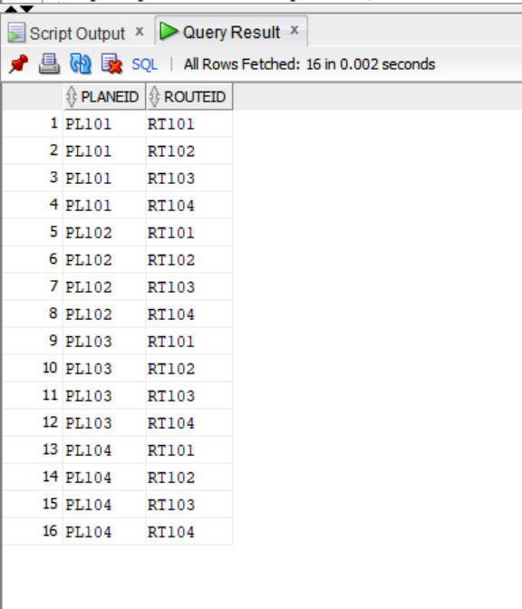OUTPUT: